Project Report

Tean ID: 699d5fd13074df695bbbb146

PROJECT TITLE

AI-Powered Customer Support & Service Automation using Salesforce Service Cloud and Agentforce

PROJECT DESCRIPTION

System Overview:
- The AI-Powered Customer Support & Service Automation system is designed to improve customer service operations for an electronics and gadgets company. The system automates support workflows, manages customer cases, and enables AI-powered responses using Salesforce technologies.
- It centralizes customer information, product details, order tracking, and support case handling within a unified platform to improve response times and service quality.

Problem Domain:
Large electronics companies receive a high number of customer requests related to:
- Product issues
- Warranty claims
- Order tracking
- Technical support
Handling these requests manually results in delayed responses, inefficient case routing, and poor visibility into case resolution performance.

Core Technology Used:
- Salesforce Service Cloud
- Salesforce Einstein AI
- Agentforce AI Service Agent
- Salesforce Flow Automation
- Customer Data Management
- Case Management System

Key Capabilities:
- Automated case management
- AI-powered customer responses
- Queue-based case assignment
- Order tracking support
- Warranty approval workflows
- Customer and product data management

Target Users:
- Customer Support Agents
- Support Managers
- Electronics Company Customers
- Service Operations Teams

Real-world Relevance:
Many global companies use CRM-based automated service systems to improve customer satisfaction and reduce operational costs. This project demonstrates how AI and automation can improve customer service efficiency.

APPLICATION SCENARIOS / USE CASES

Enterprise Usage
Large electronics companies can automate customer support operations and manage service requests efficiently.
End-user Usage
Customers can raise support cases, track their requests, and receive quick responses.
Industrial Usage
Manufacturers and electronics service providers can use automated systems to manage warranty claims and product issues.
Customer Support Centers
Customer service teams can manage thousands of support cases using automation and AI assistance.

TECHNICAL ARCHITECTURE OVERVIEW

- High-level Architecture
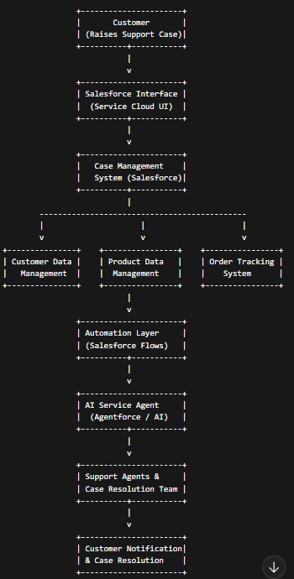

Component Interaction:
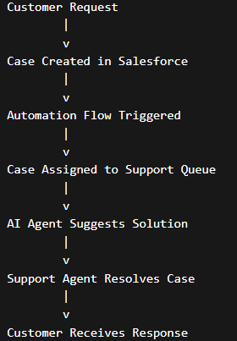
Frontend Layer
- Salesforce Lightning Interface
- Used by support agents and administrators
- Provides UI for case creation, tracking, and management
Backend Layer
- Salesforce Service Cloud logic
- Handles automation, workflows, queues, approvals, and AI responses
Database Layer
- Salesforce CRM database storing:
  - Customer records
  - Product information
  - Order data
  - Support cases
External Services
- Agentforce AI
- Salesforce Prompt Builder
Deployment Environment
- Salesforce Cloud Platform

PREREQUISITES
  - Software Requirements

- Salesforce Developer Account
- Salesforce Service Cloud
- Web Browser (Chrome / Edge)
- Salesforce Setup Console

  - Libraries / Frameworks / Dependencies

- Salesforce Flow Builder
- Salesforce Automation Tools
- Einstein AI / Agentforce

PRIOR KNOWLEDGE REQUIRED

- Salesforce CRM Fundamentals
Understanding how Salesforce manages customer data, cases, and service operations.
- Cloud Computing Basics
Knowledge of cloud platforms and how applications are hosted and accessed through the internet.
- Database Fundamentals
Understanding of objects, records, fields, and relationships within a database.
- Automation Workflows
Knowledge of workflow automation concepts such as triggers, flows, and process automation.
- AI Concepts
Basic understanding of artificial intelligence and how AI can assist in generating automated responses and insights.

PROJECT OBJECTIVES

Technical Objectives
- Develop a Salesforce-based customer support automation system.
- Implement custom objects for managing customers, products, orders, and cases.
- Configure automation workflows for case routing and approval processes.
- Integrate AI-powered assistance using Agentforce.

Performance Objectives
- Reduce the time required to respond to customer support requests.
- Improve the efficiency of case management operations.
- Minimize manual effort involved in resolving support issues.

Deployment Objectives
- Implement a cloud-based solution that can be accessed by support teams from any location.
- Ensure the system can handle multiple support requests simultaneously.

Learning Outcomes
- Gain practical experience with Salesforce Service Cloud.
- Understand the implementation of CRM automation workflows.
- Learn how AI-powered tools can enhance customer support processes.
- Develop skills in configuring Salesforce objects, flows, and security settings.

SYSTEM WORKFLOW

Step-by-step execution flow:

1. User Interaction
The workflow begins when a customer or support agent interacts with the system through the Salesforce Service Cloud interface.
Customers may raise service requests related to product issues, warranty claims, order tracking, or general inquiries.
Support agents can also manually create cases on behalf of customers when issues are reported through phone or email.

2. Input Handling
The system collects and validates the input data provided by the user. This includes:
- Customer details (name, email, phone number)
- Product information
- Order information
- Description of the issue
- Priority level of the request
Salesforce validation rules ensure that required fields are completed before the case is submitted.

3. Processing Logic
After the case is created, the system processes the request using predefined automation rules and workflows.
Salesforce Flows and Assignment Rules categorize the case based on issue type, priority, and product category.
The system determines the appropriate support queue and checks whether any approval process is required for the request.

4. Core System Execution
During core system execution, the platform performs several automated operations:
- Case is automatically routed to the appropriate support queue
- AI-powered Agentforce service agent analyzes the issue
- Suggested solutions or responses are generated
- Approval workflows are triggered if necessary (for example, warranty claims or refunds)
Support agents can then review the case details and take appropriate action.

5. Output Generation
Once the issue is processed, the system generates the output, which may include:
- Suggested AI responses for the support agent
- Case status updates (Open, In Progress, Resolved)
- Approval or rejection notifications
- Resolution details for the customer
All activities are recorded within the Salesforce system for tracking and reporting purposes.

6. Response Delivery
Finally, the resolution or response is delivered to the customer. This may occur through:
- Email notifications
- Updates within the customer service portal
- Responses from the support agent
The case is then marked as resolved or closed, and the system stores the information for future reference and performance analysis.

MILESTONE 1: REQUIREMENT ANALYSIS & SYSTEM DESIGN

9.1 Problem Definition
- Modern electronics companies receive a large volume of customer inquiries related to product issues, warranty claims, order tracking, and technical support. Traditional customer service systems rely heavily on manual handling of requests, which often results in delayed responses, inefficient case routing, and inconsistent service quality.
- Due to the absence of intelligent automation, support agents spend significant time processing repetitive queries, manually assigning cases, and documenting issue resolutions. This reduces operational efficiency and negatively impacts customer satisfaction.
- To address these challenges, the project proposes an AI-Powered Customer Support & Service Automation system using Salesforce Service Cloud, Flows, and Agentforce AI. The system aims to automate case creation, routing, approval processes, and response generation while providing AI-assisted recommendations to support agents.

  - Functional Requirements:
The system must provide the following functionalities:
- Customer Management
  - Store and manage customer information such as name, email, phone number, and customer type.
- Product Information Management
  - Maintain product details including product name, category, product code, and warranty information.
- Order Tracking
  - Allow support agents to access and track order details when resolving customer issues.
- Case Management
  - Enable support agents to create, update, and track customer support cases.
- Queue-Based Case Assignment
  - Automatically route cases to appropriate support teams such as technical support, warranty support, or order support.
- Approval Workflow
  - Certain cases such as refunds or warranty replacements require managerial approval.
- AI-Powered Assistance
  - Use Agentforce AI to generate suggested responses and summaries to assist support agents.
- Reporting and Analytics
  - Provide dashboards and reports to monitor service performance and case resolution trends.

  - Non-Functional Requirements:
Performance
The system should process customer requests quickly and efficiently.
Scalability
The system should support large volumes of customer service requests.
Security
Customer data must be protected through role-based access control and field-level security.
Reliability
The system should provide consistent service with minimal downtime.
Usability
The interface must be easy to use for support agents and administrators.
Availability
The system must be accessible through the cloud from any location with internet access.

  - System Design Decisions:
- Salesforce Service Cloud was selected as the core platform because it provides built-in CRM capabilities and service automation features. Custom objects were created to store information related to customers, products, orders, and support cases.
- Salesforce Flows were implemented to automate case routing, approval processes, and notifications. Support queues were configured to distribute cases to appropriate support teams.
- Agentforce AI was integrated into the system to assist agents by generating response suggestions and summarizing customer issues. This reduces manual workload and improves response efficiency.
- Lightning App Builder was used to customize the user interface and integrate AI functionality directly within record pages.

  - Technology Stack Selection Justification
Technology | Purpose | Justification
Salesforce Service Cloud | CRM platform | Provides customer service automation and case management
Salesforce Flow Builder | Automation | Enables automated workflows and routing
Agentforce AI | AI assistance | Generates intelligent support responses
Lightning App Builder | UI customization | Allows creation of intuitive user interfaces
Salesforce Reports & Dashboards | Analytics | Provides insights into support performance

Architecture Diagram:

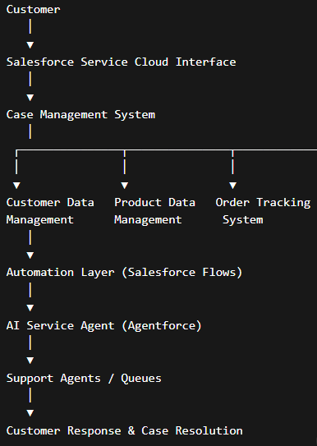

MILESTONE 2: ENVIRONMENT SETUP & INITIAL CONFIGURATION

10.1 Development Environment Setup
- Create a Salesforce Developer Account
- Enable Salesforce Service Cloud
- Access the Salesforce Setup Console
- Configure the development workspace

10.2 Dependency Installation
Since Salesforce is a cloud platform, most components are built-in.
Dependencies include:
- Salesforce Flow Builder
- Agentforce AI
- Prompt Builder
- Lightning App Builder
- Salesforce Reports & Dashboards

10.3 Project Structure Creation
Key components created in the Salesforce environment:
- Custom Objects
- Fields and Relationships
- Validation Rules
- Flows
- Queues
- Approval Processes
- AI Prompt Templates
10.4 Configuration Setup
Folder Structure (Conceptual)
project_root
│
├── objects
├── automation_flows
├── validation_rules
├── ai_prompt_templates
├── reports_dashboards
└── documentation
Setup Commands
Configuration is performed through Salesforce Setup using:
- Object Manager
- Flow Builder
- Lightning App Builder
- Security Settings
Configuration Explanation
Objects and fields were configured to manage customer support data. Automation flows were created to route cases and trigger notifications. AI prompts were configured to assist support agents with response suggestions.

MILESTONE 3: CORE SYSTEM DEVELOPMENT

  - Feature 1 – Case Management System

The core functionality of the system is the Customer Case Management Module. Custom objects were created in Salesforce to manage customers, products, and service cases. The system allows support agents to create and manage cases related to customer complaints and product issues.
The following objects were implemented:
- Customer
- Merchandise
- User Case
- Order
Relationships were created between objects to maintain data integrity.
Example:
Customer → User Case
Merchandise → User Case
This allows support teams to track which customer raised a case and which product is involved.
Custom fields were created using Object Manager to capture relevant information such as:
- Case Type
- Priority
- Status
- AI Summary
Lookup relationships were used to link Customer and Merchandise with User Case records.
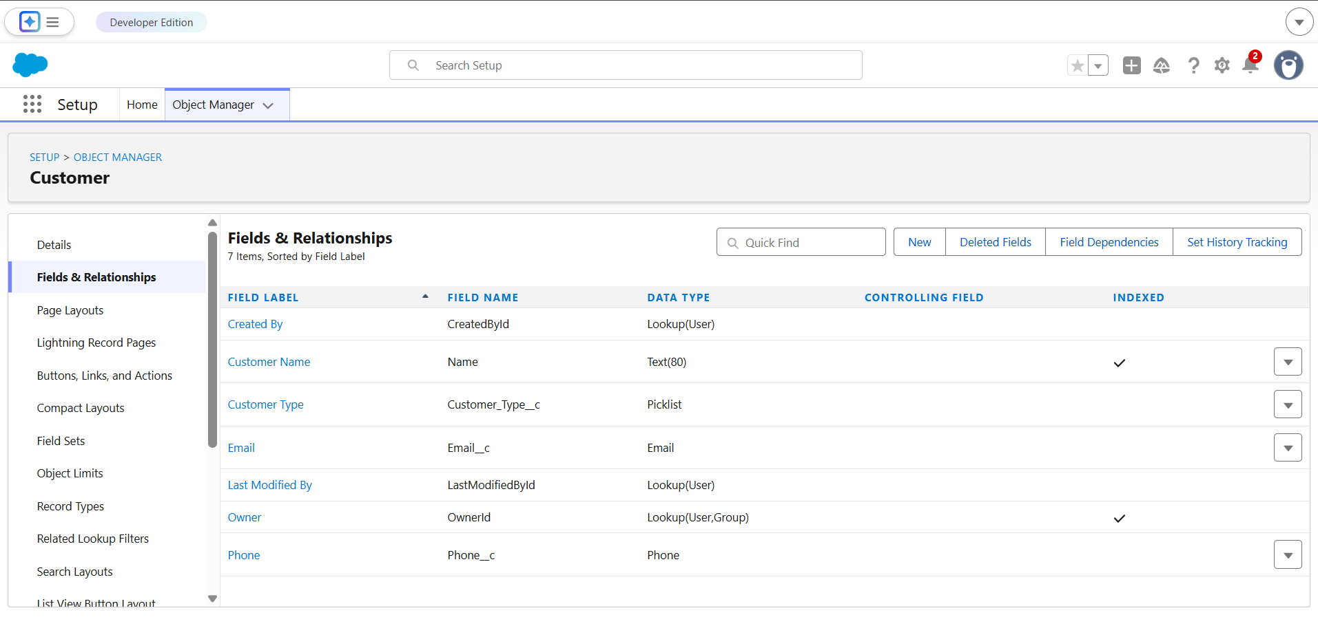
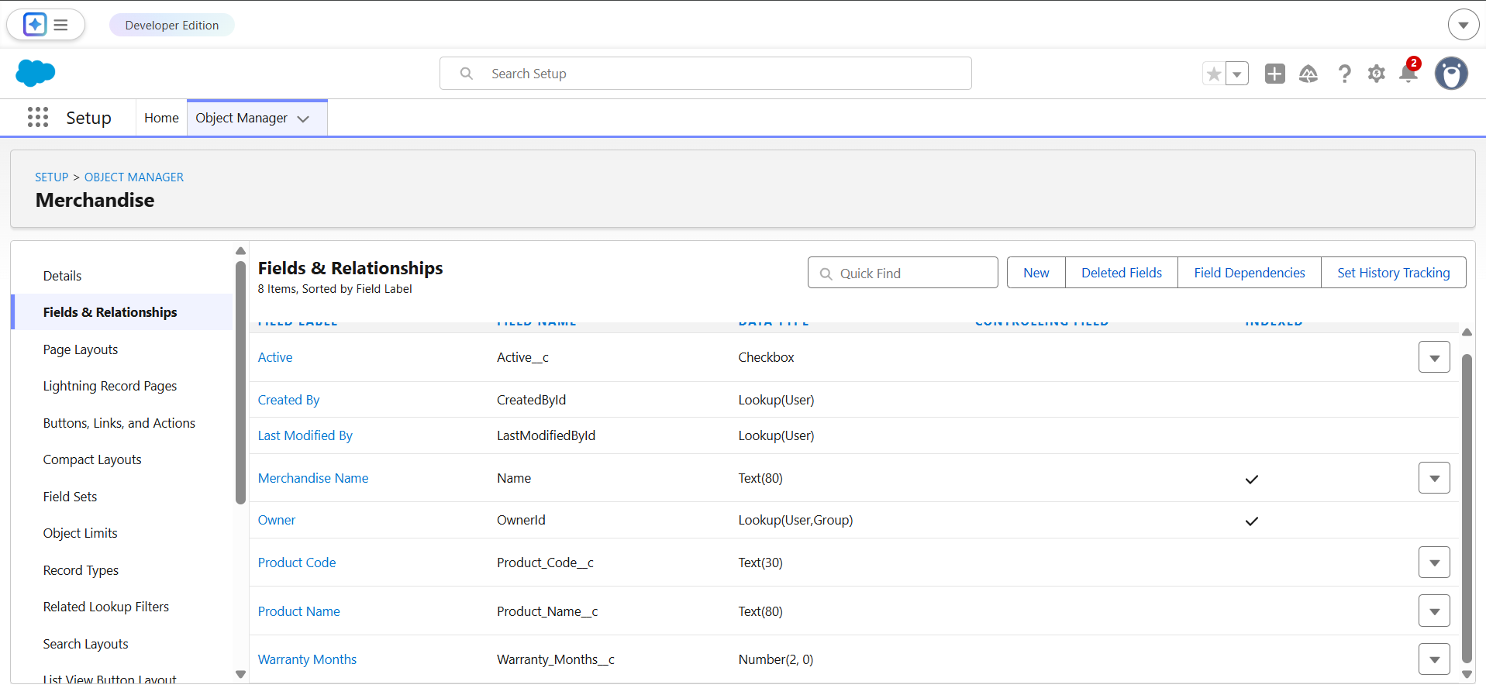
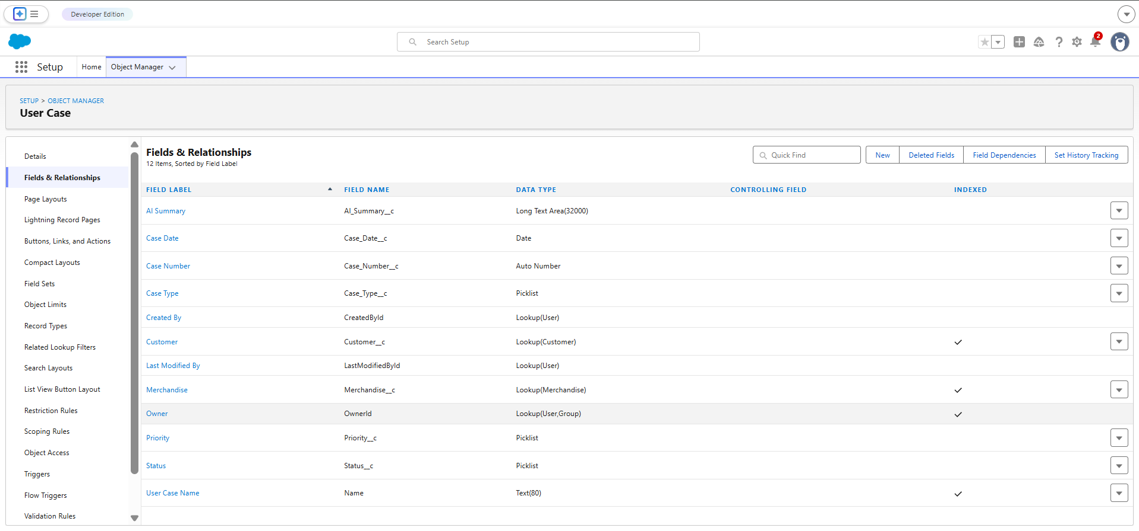
  - Feature 2 – Automation Using Salesforce Flow
Automation workflows were implemented using Salesforce Flow Builder to automate case assignment and support operations. These flows reduce manual work and ensure that cases are routed to the correct support teams.
The automation system performs the following tasks:
- Automatically assigns cases to support queues
- Updates case status
- Routes high-priority cases to specific users
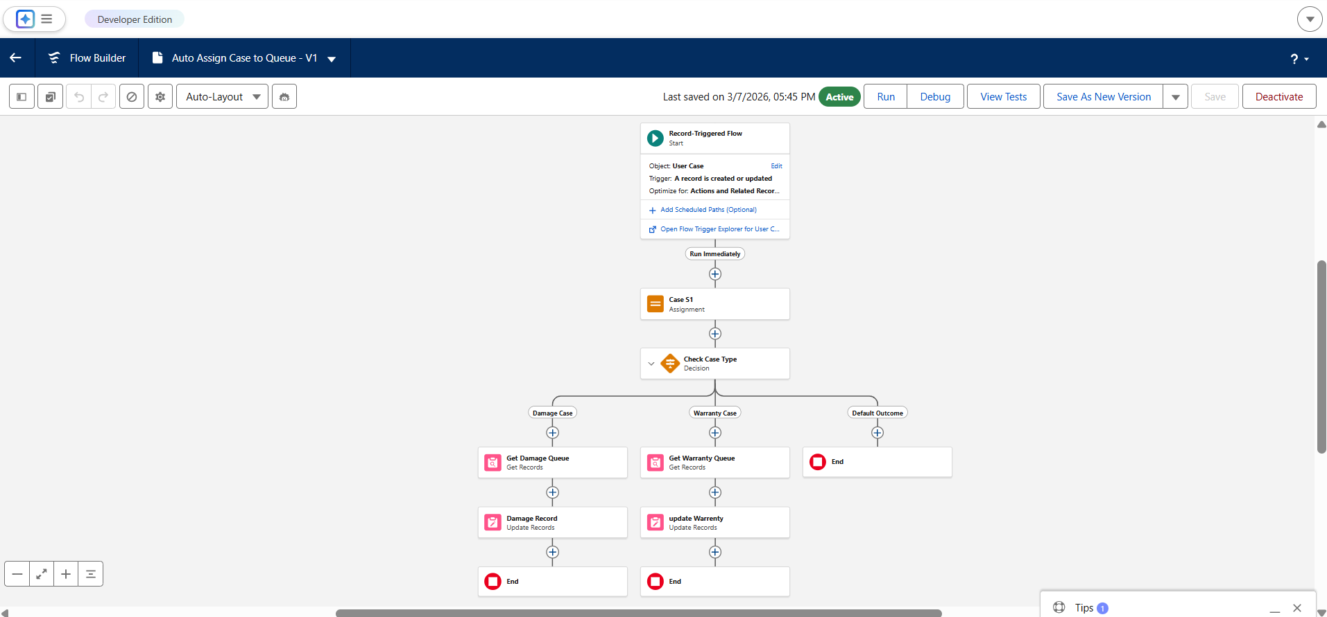
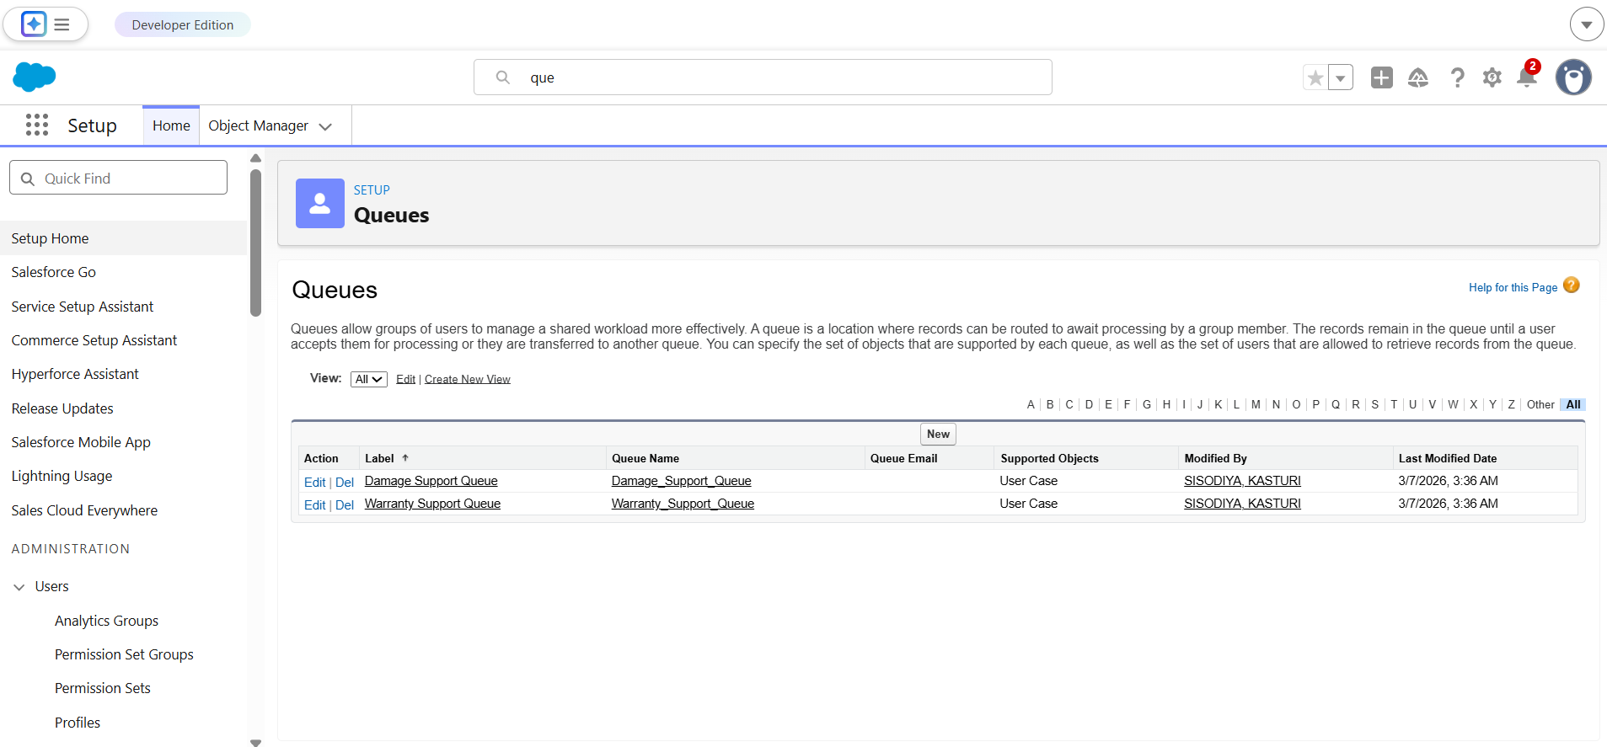

  - Feature 3 – AI Case Summary using Einstein AI
The system integrates Salesforce Einstein Generative AI to automatically generate summaries of customer cases. Using Prompt Builder, an AI prompt template was created to analyze case data and generate a professional summary.
The AI summary helps support agents quickly understand the issue without manually reviewing all case details.
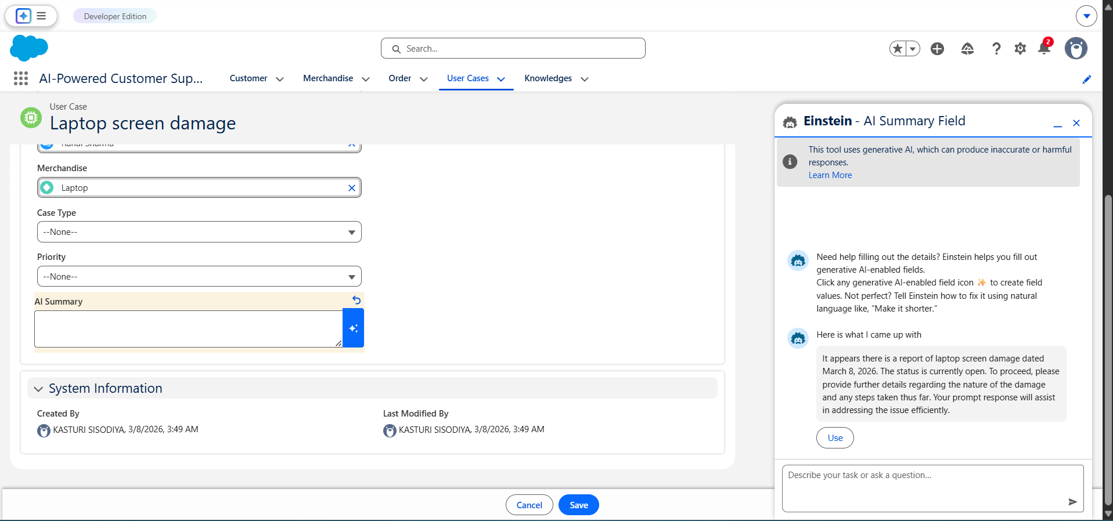
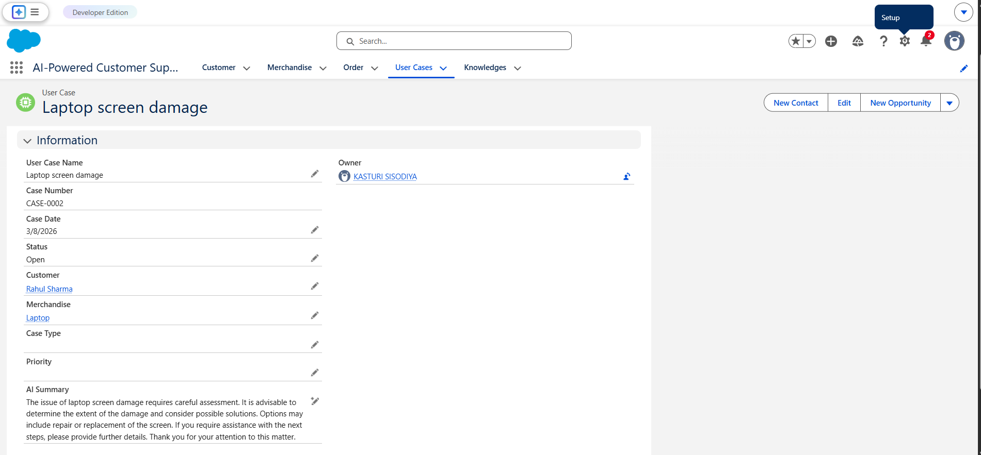

- MILESTONE 4: INTEGRATION & OPTIMIZATION

12.1 Component Integration
All system components were integrated within a single Salesforce Lightning application. Custom objects, automation flows, queues, and AI prompt templates were connected to provide a unified support management platform.
The Lightning App allows users to access:
- Customer records
- Product information
- Customer support cases
- AI-generated summaries
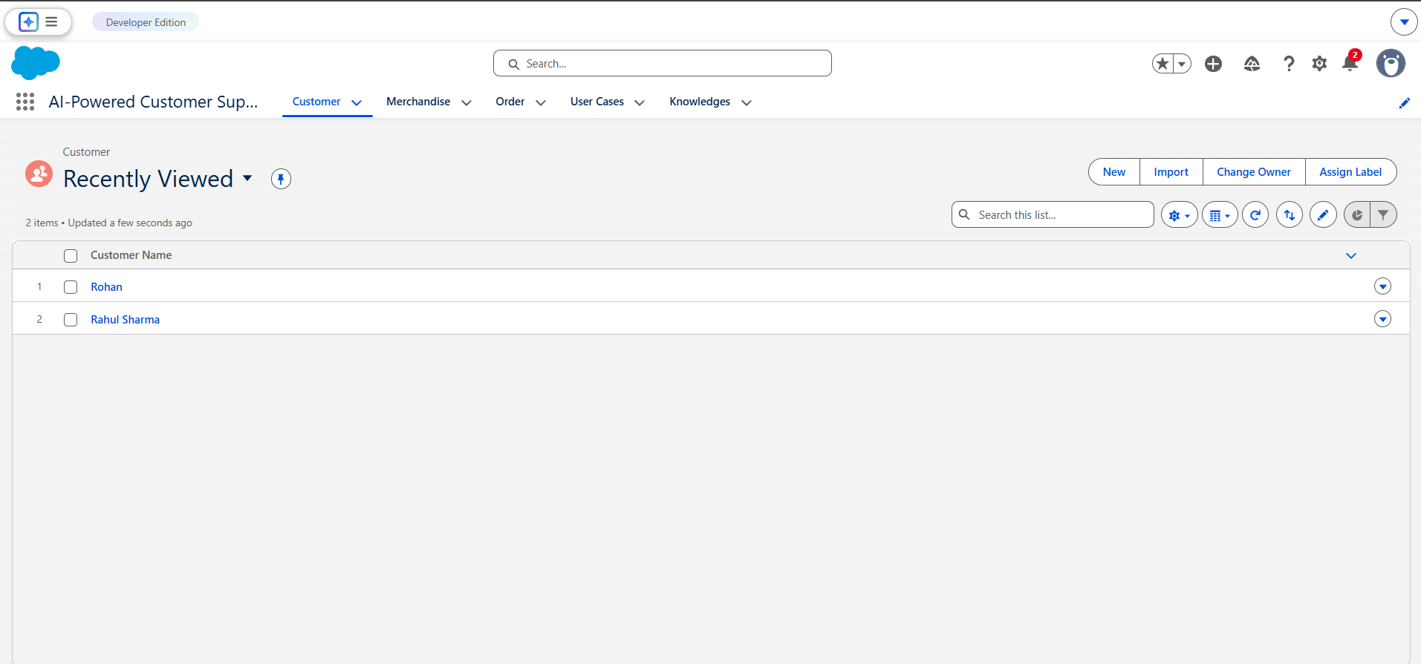
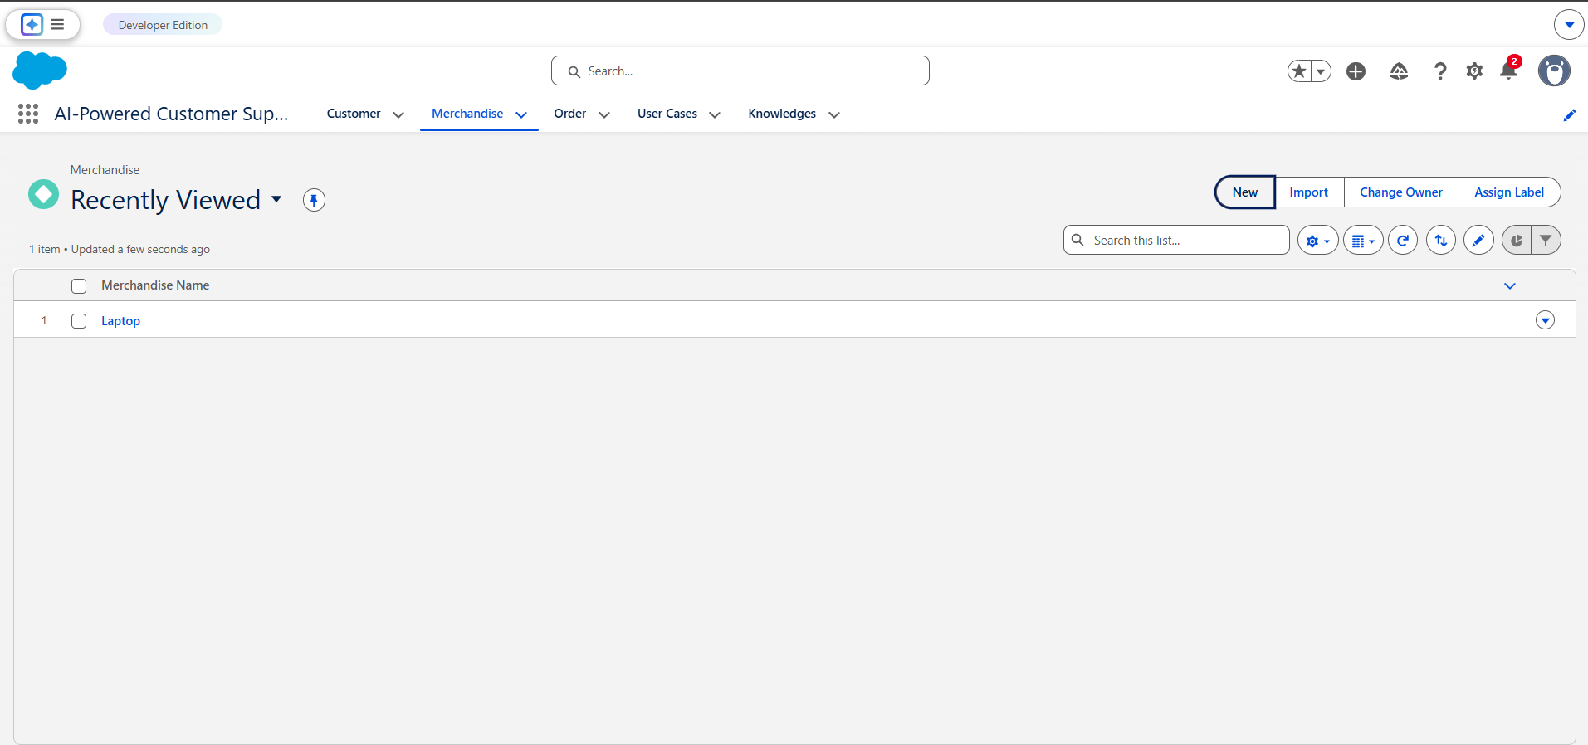
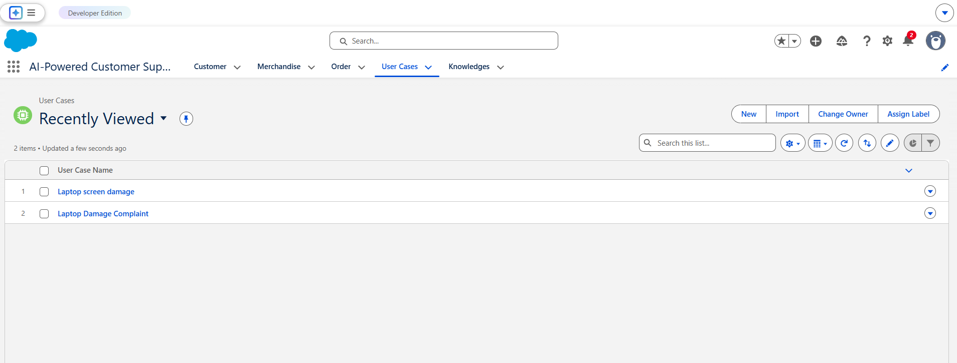

12.2 Performance Optimization
Automation workflows were optimized to minimize manual work and improve system efficiency. Record-triggered flows ensure immediate case assignment and status updates.

12.3 Security Enhancements
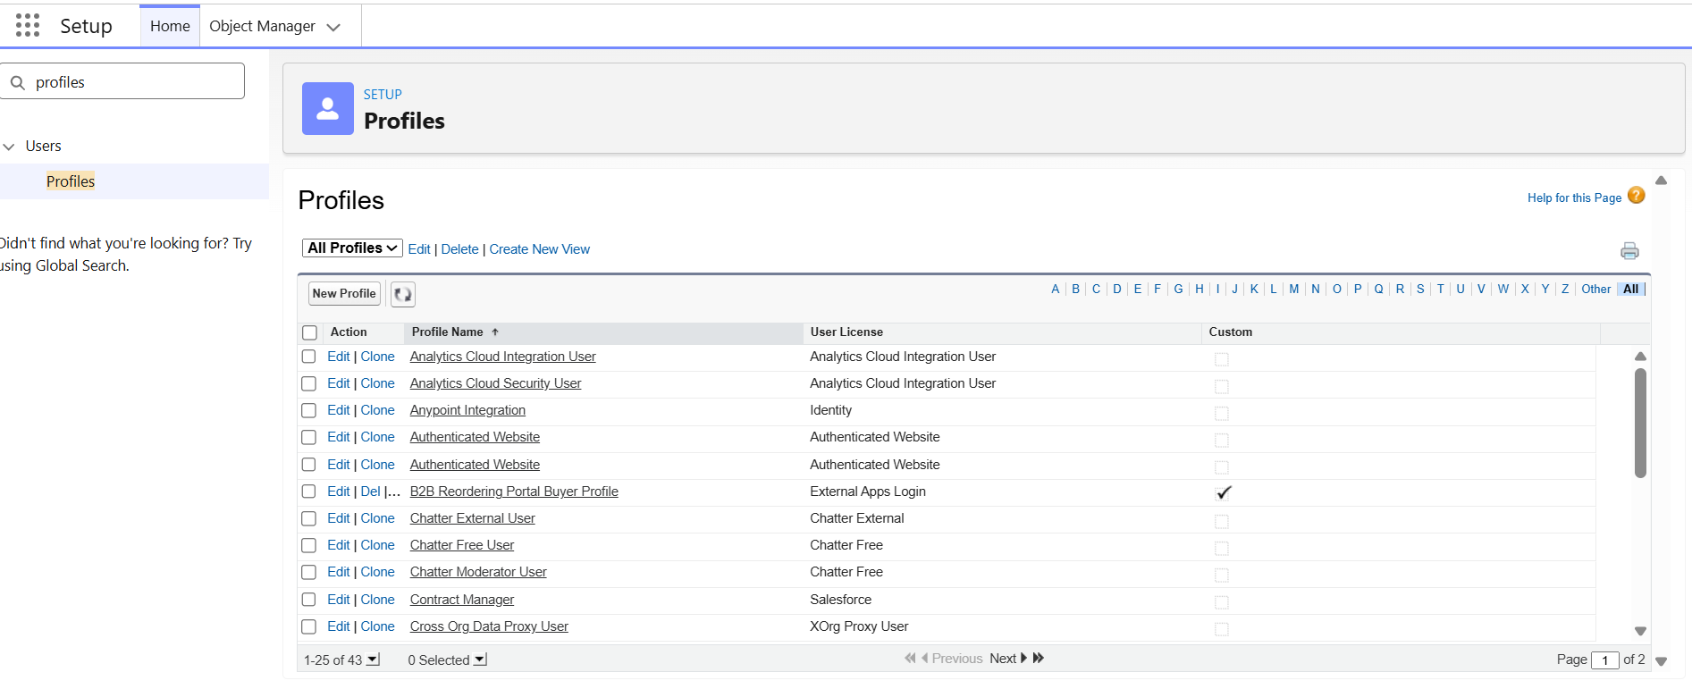
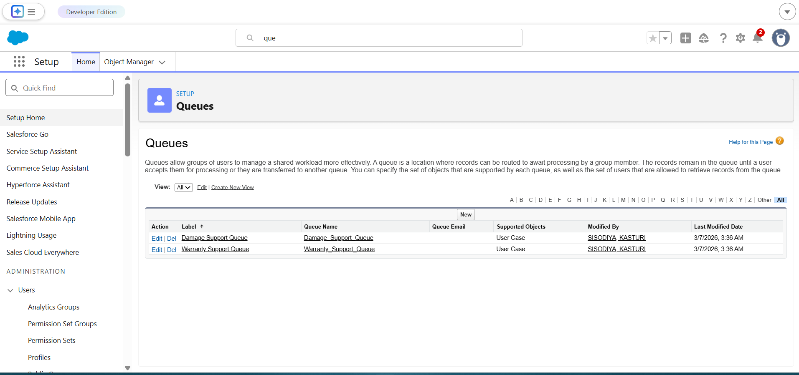

12.4 Error Handling & Validation
Validation rules were implemented to prevent invalid data entry. For example, if the case type is Damage, the system requires priority to be selected.

MILESTONE 5: TESTING & VALIDATION
  - Test Cases
Test Case ID | Input | Expected Output | Status
TC01 | Create User Case | Case created successfully | Pass
TC02 | Case Type = Damage without priority | Error message | Pass
TC03 | AI Summary generation | AI summary generated | Pass
TC04 | Case assignment | Assigned to queue | Pass

DEPLOYMENT
  - Deployment Architecture: The system is deployed on the Salesforce Cloud platform.
  - Hosting Platform : Salesforce CRM Cloud
  - Deployment Steps:
• Configure Salesforce environment
• Create objects
• Implement flows
• Configure AI prompt templates
• Deploy Lightning App

PROJECT STRUCTURE

project_root/
│
├── src/
├── config/
├── static/
├── templates/
├── database/
├── tests/
├── main_application_file
└── requirements.txt

1. src/
This folder contains the core application logic of the project.
In the Salesforce implementation, this corresponds to:
- Automation workflows (Flows)
- Business logic
- Queue assignment logic
- AI prompt configuration
The src layer manages how cases are created, processed, and routed within the system.
Example components included:
- Case Assignment Flow
- SLA Flow
- Prompt Builder AI logic
- Business automation rules

2. config/
The config folder stores system configuration settings.
In this project, it represents:
- Salesforce object configurations
- Field definitions
- Validation rules
- Security settings
- Queue configurations
These configurations define how the system behaves and how data is structured.

3. static/
The static folder contains static assets used in the application interface.
Examples include:
- UI images
- icons
- branding assets
- Lightning App design elements
These elements improve the visual interface of the system.

4. templates/
This folder contains UI layout templates and page configurations.
In the Salesforce environment, this corresponds to:
- Lightning record pages
- Dynamic forms
- Page layouts
- Lightning App configuration
These templates control how users interact with the system interface.

5. database/
The database folder represents the data storage layer of the system.
In this project, Salesforce objects act as the database tables.
Main data entities include:
- Customer Object
- Merchandise Object
- User Case Object
- Order Object
Relationships between these objects form the system’s data schema.

6. tests/
This folder includes test cases and validation procedures used to verify system functionality.
Testing activities include:
- Flow testing
- Validation rule testing
- Case creation testing
- AI summary generation testing
Test cases ensure the reliability of the automation system.

7. main_application_file
This represents the main application entry point.
In this project, the main application is the Lightning App created in Salesforce:
AI-Powered Customer Support & Service Automation
The Lightning App integrates all objects, automation flows, and AI features into a unified interface.

8. requirements.txt
This file normally lists software dependencies.
For this Salesforce-based project, the requirements include:
- Salesforce CRM Platform
- Salesforce Lightning Experience
- Salesforce Flow Builder
- Einstein Generative AI
- Prompt Builder
- Reports & Dashboards
These tools provide the functionality required to implement the system.

RESULTS

- System Output:
- The developed system allows support agents to create and manage customer cases through the Salesforce Lightning App. When a case is created, the system automatically performs several operations including case assignment, validation checks, and AI summary generation.
- Key outputs of the system include:
- • Successful creation and management of customer cases
• Automated routing of cases to appropriate support queues
• AI-generated summaries of case details
• Centralized access to customer and product information
• Visual insights through reports and dashboards
- The system ensures that customer issues are processed efficiently while minimizing manual effort.
- Performance Evaluation:
- The performance of the system was evaluated based on its automation capabilities and response time in handling customer cases.
- The automation features implemented using Salesforce Flow Builder significantly reduced manual intervention. Case assignment and status updates occur instantly after record creation.
- Einstein AI integration provides quick summaries of case details, enabling support agents to understand issues faster and respond more effectively.
- Overall, the system improves operational efficiency and reduces case handling time.
- Screenshots:
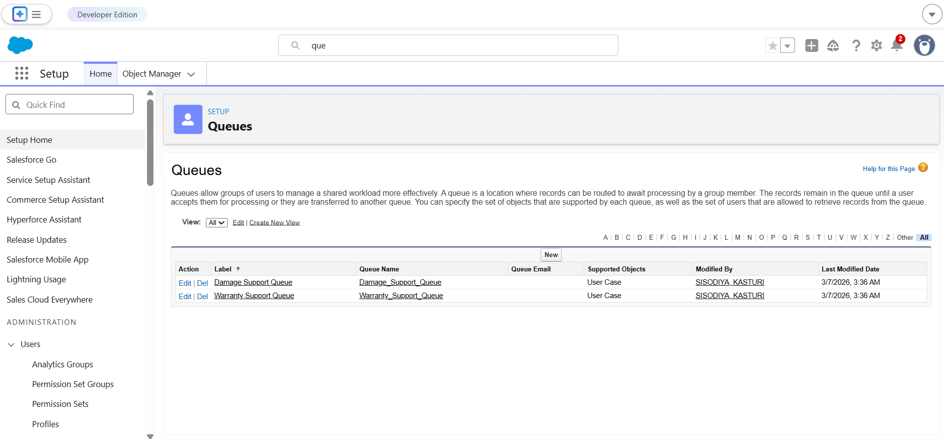
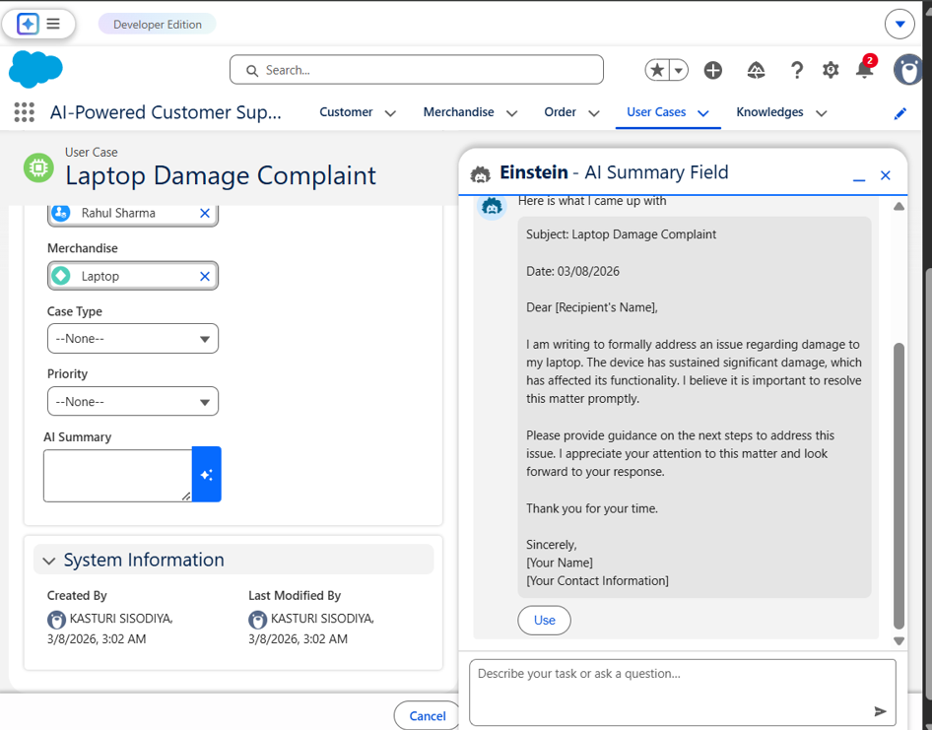
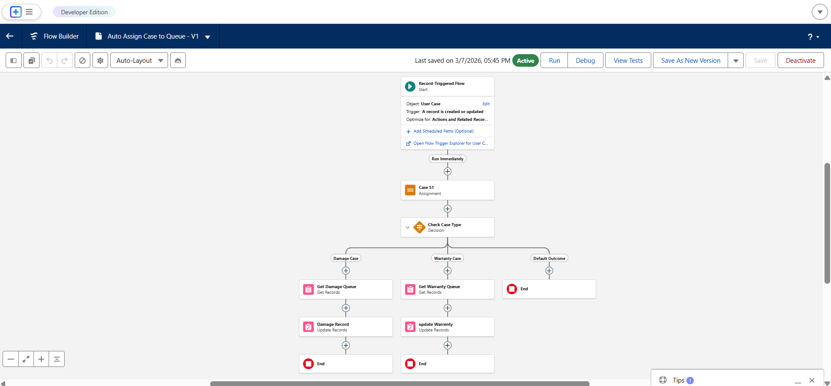

ADVANTAGES & LIMITATIONS

The AI-Powered Customer Support & Service Automation system provides several benefits that improve the efficiency of customer support operations.
1. Automated Case Management
The system automatically manages customer cases using Salesforce automation tools, reducing manual work for support agents.
2. Faster Issue Resolution
Automated case routing and AI-generated summaries help support teams quickly understand and resolve customer issues.
3. Improved Productivity
By automating repetitive tasks such as case assignment and status updates, the system allows support agents to focus on more complex customer problems.
4. AI-Powered Insights
Integration of Einstein Generative AI enables automatic generation of case summaries, helping agents understand case details faster.
5. Centralized Data Management
All customer, product, and case data are stored in a centralized Salesforce platform, making information easily accessible.
6. Scalable Cloud Platform
Since the system is built on the Salesforce cloud platform, it can easily scale as the number of users or cases increases.

Limitations
Although the system provides several advantages, there are some limitations.
1. Dependency on Salesforce Platform
The system relies entirely on the Salesforce environment, which requires access to the platform.
2. Limited Customization Without Apex
Advanced customizations may require Apex programming, which was not implemented in this project.
3. AI Summary Requires Manual Trigger
Currently, the AI summary generation requires user interaction to generate the output.
4. Limited External Integration
The project does not include integration with external CRM systems or third-party services.

FUTURE ENHANCEMENTS

The project can be further improved by adding additional features and integrations.
18.1 Scalability Improvements
The system can be enhanced to support a larger number of users and customer cases by implementing advanced automation and optimized workflows.
18.2 Feature Expansion
Additional features such as case prioritization dashboards, automated email notifications, and real-time alerts can be implemented to improve support efficiency.
18.3 Cloud Integration
The system can be integrated with other cloud services and external platforms such as payment systems, logistics services, or third-party customer support tools.
18.4 Mobile Integration
A mobile application or Salesforce mobile interface can be integrated to allow support agents to manage cases directly from mobile devices.
18.5 Advanced Automation
Future improvements may include:
- AI-based case categorization
- Automated escalation of unresolved cases
- Integration with AI chatbots for instant customer support
These enhancements will further improve the performance and usability of the system.

CONCLUSION

- The AI-Powered Customer Support & Service Automation project demonstrates how Salesforce technology can be used to streamline and automate customer support operations.
- The system successfully integrates several Salesforce components such as custom objects, automation flows, validation rules, queues, security settings, and Einstein Generative AI to create an intelligent support management platform.
- The implementation shows how automation can reduce manual work, improve response time, and enhance the productivity of support teams. The addition of AI-based case summaries further improves the efficiency of support agents by providing quick insights into customer issues.
- Overall, the project highlights the potential of Salesforce as a powerful platform for building automated customer service solutions and demonstrates practical applications of cloud-based CRM technologies in modern business environments.

APPENDIX
- Live Demo link:
- GitHub Repository Link :

